# SUPERMARKET MANAGEMENT

**RITHANYAA S [23X038]**

**RISHIKA M [23X037]**

**SANJIV KUMAR A [23X042]**

DISSERTATION SUBMITTED IN PARTIAL FULFILLMENT OF THE REQUIREMENTS FOR THE DEGREE OF

**BACHELOR OF SCIENCE**

**COMPUTER SYSTEMS AND DESIGN**

OF ANNA UNIVERSITY



**DEPARTMENT OF APPLIED MATHEMATICS AND COMPUTATIONAL SCIENCES**

**PSG COLLEGE OF TECHNOLOGY**

**(Autonomous Institution)**

**COIMBATORE - 641004**

**CONTENTS**

**CHAPTER**

**ACKNOWLEDGEMENT**

**SYNOPSIS**

1. INTRODUCTION

1.1 ORGANIZATION PROFILE

1.2 PROJECT OVERVIEW

1.3 SYSTEM CONFIGURATION

1.4 TOOLS AND TECHNOLOGIES USED

2. SYSTEM ANALYSIS

2.1 PROPOSED SYSTEM

2.2 REQUIREMENT SPECIFICATIONS

2.3 HTML/CSS

2.4 JAVASCRIPT & JQUERY

2.5 PHP

2.6 MYSQL

2.7 SQL DATABASE

2.8 NOTEPAD++

2.9 XAMPP

3. SYSTEM DESIGN

3.1 FLOW CHART & TABLE USED

4. SYSTEM IMPLEMENATION

4.1 USER REGISTRATION PAGE

4.USER LOGIN

4.3 MAIN WEBPAGE

4.4 PRODUCT LISTING

4.5 ADD TO CART AND CHECKOUT

4.6 REVIEW AND RATING SYSTEM

4.7 ADMIN FUNCTIONS

4.8 ADD, EDIT & DELETE PRODUCT

5. SYSTEM TESTING

5.1 FUNCTIONAL TESTING

5.2 USER INTERFACE TESTING

6. CONCLUSION

7. BIBLIOGRAPHY

ACKNOWLEDGEMENT

We are extremely grateful to **Dr. Prakasan K**, Principal, PSG College of Technology, for giving me this opportunity to do my project .

We are deeply indebted to **Dr. Nadarajan R**, Director, PSG Institute of Applied Mathematics and Computational Sciences, for his continual support throughout my project.

We express my gratitude to **Dr. Shina Sheen**, Professor and Head, Department of Applied Mathematics and Computational Sciences, PSG College of Technology, for her motivation.

We are indebted to **Dr. S Poomagal**, Professor, Programme Coordinator, Department of Applied Mathematics and Computational Sciences, PSG College of Technology for his encouragement and persistent support.

We extend my gratitude to my tutor **Dr. N Brindha**, Assistant Professor (Sr. Grade), Department of Applied Mathematics and Computational Sciences, PSG College of Technology, for his support.

we am highly obliged to my academic guide **Dr. Priya R**, Department of Applied Mathematics and Computational Sciences, PSG College of Technology, for his continual support and enduring guidance throughout my project tenure.

Finally, we express my gratefulness to all the staff of Department of Applied Mathematics and Computational Sciences, PSG College of Technology, Coimbatore and my family and friends for their encouragement and support.

SYNOPSIS

A comprehensive system designed to streamline supermarket operations and enhance customer experience. It features a dual-role login system for administrators and users, enabling efficient product management and a convenient online shopping platform.

**Key Features:**

* **Product Management:** Add, edit, delete, and view products.
* **Inventory Tracking:** Monitor stock levels and reorder when necessary.
* **Sales and Reporting:** Track sales, generate reports, and analyze performance.
* **Customer Management:** Store customer information and preferences.
* **Online Shopping:** Browse products, add to cart, and checkout.

**Benefits:**

* **Improved Efficiency:** Streamlines operations and reduces manual tasks.
* **Enhanced Customer Experience:** Provides a convenient online shopping platform.
* **Data-Driven Decisions:** Enables informed decision-making based on sales data.

**Technology:**

* **Frontend:** HTML, CSS, JavaScript, and a suitable framework (e.g., React, Angular).
* **Backend:** Programming language (e.g., Python, Java) and a web framework (e.g., Django, Spring Boot).
* **Database:** A relational database (e.g., MySQL, PostgreSQL) to store data.

**Future Enhancements:**

* **Mobile App:** Develop a mobile app for on-the-go shopping.
* **Loyalty Program:** Implement a loyalty program to reward customers.
* **Integration with Payment Gateways:** Facilitate seamless online payments.

This system provides a robust solution for supermarkets, combining efficient operations with a user-friendly online shopping experience.

**CHAPTER 1**

**INTRODUCTION**

A comprehensive system for efficient supermarket operations and enhanced customer experience. Features include product management, inventory tracking, sales reporting, customer management, and online shopping.

**1.1 ORGANIZATION PROFILE**

**Supermarket Management System** is a comprehensive e-commerce platform designed to streamline supermarket operations and enhance customer experience. Launched in [Year], our platform offers a wide range of products, from fresh produce to household essentials.

Customers can easily browse our catalog, add items to their cart, and checkout securely. Our system is designed to improve efficiency for administrators, allowing them to manage inventory, track sales, and analyze customer behavior.

We leverage advanced technologies to ensure a smooth and efficient experience for both customers and staff. With a focus on innovation and customer satisfaction, Supermarket Management System is committed to providing a top-notch online shopping platform

**1.2 PROJECT OVERVIEW**

**Supermarket Management System** is an e-commerce platform designed to streamline supermarket operations and enhance customer experience. The platform offers a user-friendly interface for customers to browse a wide range of products, add items to their cart, and checkout securely.

For administrators, the system provides tools to manage inventory, track sales, and analyze customer behavior. The platform is built with a focus on efficiency, reliability, and responsiveness to ensure a seamless experience for all stakeholders.

**1.3 SYSTEM CONFIGURATION**  
 The system configuration used during the development of the project is specified in this section.

**1.3.1 HARDWARE CONFIGURATION**

* **Processor (CPU):** Intel(R) Core(TM) i3-8145U CPU @ 2.10GHz 2.30 GHz
* **RAM:** 12.0 GB
* **Storage:** 1TB SSD
* **Operating System:** Windows 10

**1.3.2 SOFTWARE CONFIGURATION**

* **Operating System:** Windows 10/11
* **Frontend Technologies:** HTML, CSS, JavaScript
* **Backend Technologies:** PHP
* **Database:** MySQL
* **Development Tools:** Notepad ++, XAMPP (for local PHP server and MySQL)

**1.4 TOOLS AND TECHNOLOGIES USED**

This section provides a brief description of the tools and technologies used in developing the supermarket management project.

**1.4.2 HTML**

HTML stands for Hyper Text Markup Language. A Markup Language is a set of markup tags. HTML documents are described by HTML tags. Each HTML tag describes different document content. Hypertext Markup Language, a standardized system for tagging text files to achieve font, color, graphic, and hyperlink effects on World Wide Web pages

Default characteristics for every item of HTML markup are defined in the browser. HTML describes the structure of a website semantically and, before the advent of Cascading Style Sheets (CSS), included cues for the presentation or appearance of the document (web page), making it a markup language, rather than a programming language. HTML can embed scripts written in languages such as JavaScript which affect the behavior of HTML web pages.

**1.4.2 CSS**

CSS stands for Cascading Style Sheets. CSS describes how HTML elements are to be displayed on screen, paper, or in other media. CSS saves a lot of work. It can control the layout of multiple web pages all at once. CSS covers fonts, colors, margins, lines, height, width, background images, advanced positions and many other things. It is a web page derived from multiple sources with a defined order of precedence where the definitions of any style element conflict.

**1.4.3 PHP**

The term PHP is an acronym for – Hypertext Preprocessor. PHP is a server-side scripting language created primarily for web development but it is also used as a general-purpose programming language. Unlike client-side languages like JavaScript, which are executed on the user’s browser, PHP scripts run on the server. The results are then sent to the client’s web browser as plain HTML. It can be integrated with many databases such as Oracle, Microsoft SQL Server, MySQL, PostgreSQL, Sybase, and Informix.

**1.4.4 MySQL**

MySQL Database is a client/server system that consists of a multithreaded SQL server that supports different back ends, several different client programs and libraries, administrative tools, and a wide range of application-programming interfaces (APIs). We also provide MySQL as an embedded multithreaded library that you can link into your application to get a smaller, faster, easier-to-manage standalone product. MySQL is the database management system used to store and manage data for supermarket. The platform uses MySQL to handle user information, product details, orders, and payment records. It is known for its reliability and ability to handle large datasets efficiently.

**1.4.5 JavaScript**

JavaScript enhances the user experience by enabling dynamic interaction on the website. It is used to implement features like shopping carts, form validation, and real-time updates on product availability. By leveraging these tools and technologies, supermarket offers an efficient, responsive, and user-centric e-commerce solution, tailored to meet the demands of modern online shoppers while maintaining seamless management for admins.

### CHAPTER 2

### SYSTEM ANALYSIS

#### 2.1 PROPOSED SYSTEM

The proposed system for "Supermarket management" aims to streamline the shopping experience by providing a user-friendly interface that enables customers to browse cproducts, view details such as descriptions and prices, and place orders online. The system caters to both customers and admins. Customers can easily add products to their carts and proceed to checkout, while admins can manage products and view order details, shipping status, and payment records. The implementation of this system will allow Supermarket to scale its operations efficiently and provide a seamless shopping experience for customers.

#### 2.2 REQUIREMENT SPECIFICATIONS

Software Requirements Specifications (SRS) for "Supermarket " outlines both functional and non-functional needs for the system's success.

##### 2.2.1 FUNCTIONAL REQUIREMENTS

* **User registration and login**: Users can sign up as customers or admins and securely log in.
* **Product listing**: Customers can browse various categories and view products with images, descriptions, and prices.
* **Cart management**: Users can add, update, or remove items from their shopping cart.
* **Order placement**: Customers can place an order, receive an order confirmation, and review details before making a purchase.
* **Payment gateway**: Users can make payments using available methods, and payments will be processed securely.
* **Review**: Customers can add review about their shopping experience and the products.
* **Admin features**: Admins can add, edit, and delete products, as well as manage order statuses and view payment information.

##### 2.2.2 NON-FUNCTIONAL REQUIREMENTS

* **Usability**: The system must offer a smooth user interface, easy navigation, and a clear checkout process to ensure a seamless shopping experience.
* **Scalability**: The system should be designed to handle a growing user base and increased data without performance degradation.
* **Security**: User authentication and data encryption must be in place to protect sensitive information, such as login credentials and payment details.
* **Performance**: The system should offer fast response times, even when multiple users are simultaneously browsing and making purchases.
* **Extensibility**: The system should allow for future expansion, such as adding new features or payment methods.

#### 2.3 HTML/CSS

HTML (Hypertext Markup Language) is the backbone of the web pages for Supermarket . It structures the layout of the web application, while CSS (Cascading Style Sheets) is used for designing the visual aspects. The combination of these technologies helps in creating a visually appealing, responsive, and interactive online store for Supermarket .

* **HTML**: Used for the structural setup of the website. It defines the structure of pages like product lists, cart, checkout, and user profiles.
* **CSS**: Responsible for the visual presentation, including styling elements like fonts, colors, spacing, and layouts to ensure the website is both visually attractive and user-friendly.

#### 2.4 JAVASCRIPT AND JQUERY

JavaScript is used to provide dynamic functionality to Supermarket 's interface, making it interactive and responsive.

#### 2.5 PHP

PHP (Hypertext Preprocessor) serves as the backend programming language for Supermarket , enabling communication between the front end and the database.

* **Role in Supermarket** : PHP handles server-side logic, such as processing user registrations, logging in, managing the cart, placing orders, and communicating with the database to retrieve and store data.

PHP is also responsible for sending confirmation emails and handling the admin functionalities like product management.

##### 2.6 MySQL

MySQL, part of the XAMPP package, was used as the database management system. It stores information about users, products, orders, payments, and reviews. It is used to create and manage tables for users, products, orders, and payments. Queries are run using SQL to retrieve and manipulate this data as needed.

#### 2.7 SQL DATABASE

The SQL database is the backbone of data storage for the Supermarket project.

**Entities:**

* **CUSTOMER_REGISTER** (Customer entity)
  + Attributes: id (PK), username, password, dob, address, state, country, mobile, email, created_at
* **PRODUCTS** (Product entity)
  + Attributes: id (PK), name, category, price, stock_quantity
* **PRODUCT_REVIEWS** (Product Review entity)
  + Attributes: id (PK), product_name, category, rating, quality, suggestion, created_at
* **CART** (Cart entity)
  + Attributes: id (PK), customer_id (FK to CUSTOMER_REGISTER), product_id (FK to products), quantity

#### 2.8 NOTEPAD++

Notepad++ is a versatile text editor used for the development of Supermarket . It is lightweight, easy to use, and allows developers to write and manage code for different languages such as HTML, CSS, JavaScript, PHP, and SQL all in one place.

* **Features of Notepad++**:
  + Syntax highlighting for various programming languages.
  + Plugin support for extending functionality.
  + Auto-completion and code suggestions for faster development.

##### 2.9 XAMPP

XAMPP provided a local development environment, hosting the Apache server and MySQL database for running the PHP-based website.

**CHAPTER 3**

**SYSTEM DESIGN**

This phase reviews system style. Solutions style is the procedure of specifying components of a system like components design, elements together with their user interfaces, together with information for a system based upon the defined needs.

**FIGURE 3.1 SYSTEM FLOW**

**Tables Used:**

### CUSTOMER_REGISTER

* Stores customer information and unique identifiers.
* Includes personal details (name, dob, address).
* Contains contact information (mobile, email).
* Tracks account creation timestamp.
* Enables user management and interactions.

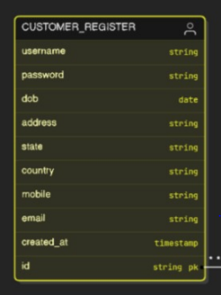

### products

* Contains product details and unique identifiers.
* Includes names, categories, and pricing.
* Tracks available stock quantity.
* Facilitates product management and inventory control.

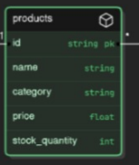

### product_reviews

* Captures customer feedback on products.
* Includes ratings and quality assessments.
* Allows for suggestions and improvements.
* Tracks submission timestamps for reviews.

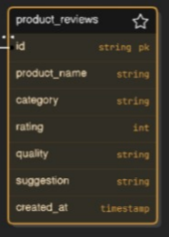

### cart

* Represents the shopping cart for customers.
* Links customers to selected products.
* Includes product identifiers and quantities.
* Manages pending purchases before checkout.

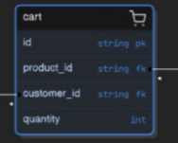

**3.2 ER DIAGRAM**

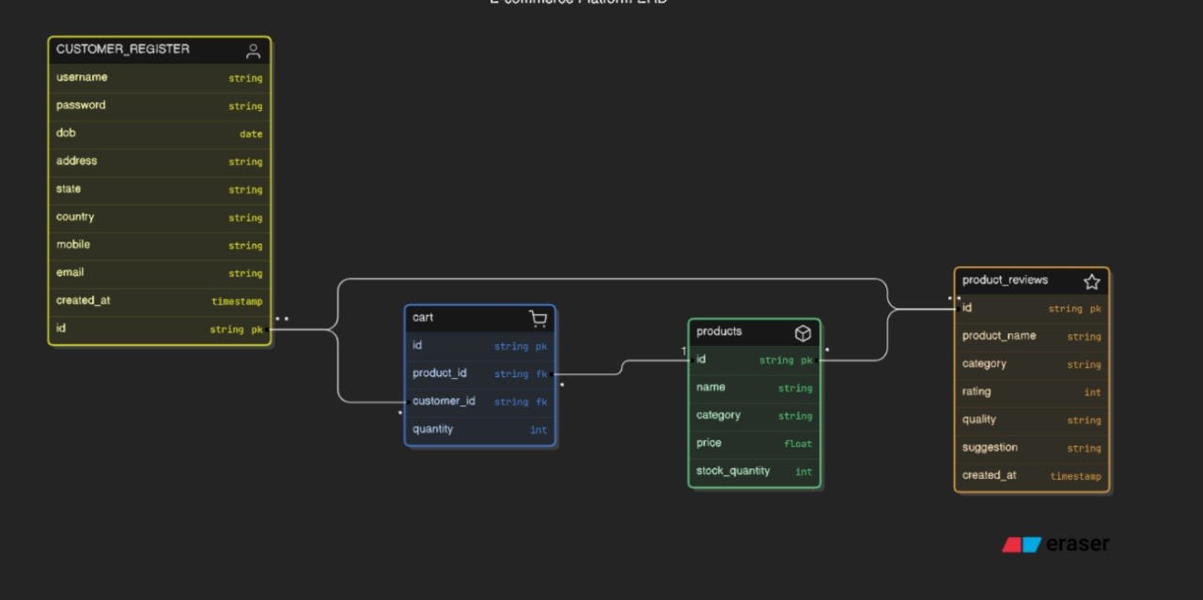

**CHAPTER 4**

**SYSTEM IMPLEMENTATION**

This interface allows both customers and administrators to log in to the system using their registered credentials. Administrators will have access to manage products, orders, and customer reviews, while customers can browse the product catalog and place orders.

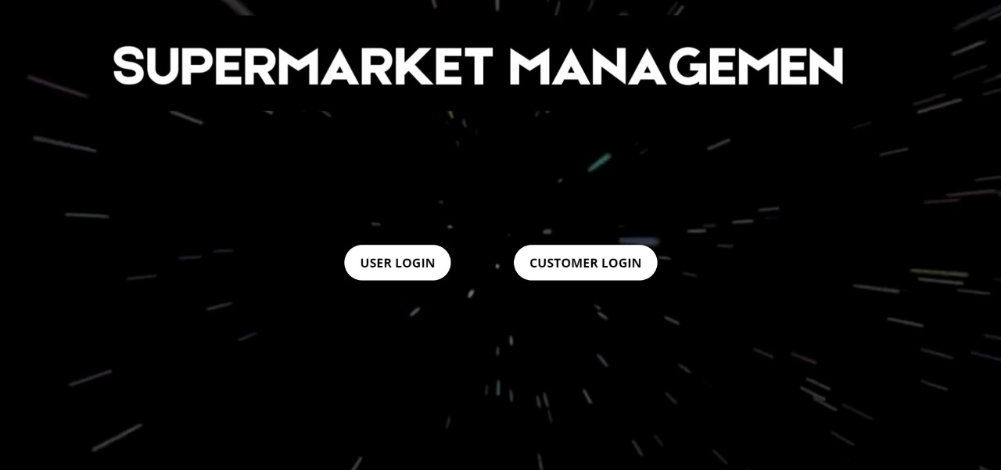

## 4.1 ADMIN REGISTRATION

Users, including customers and admin, can easily register in the system using their basic details. Admins have access to add products, delete product, view product and modify a product name.

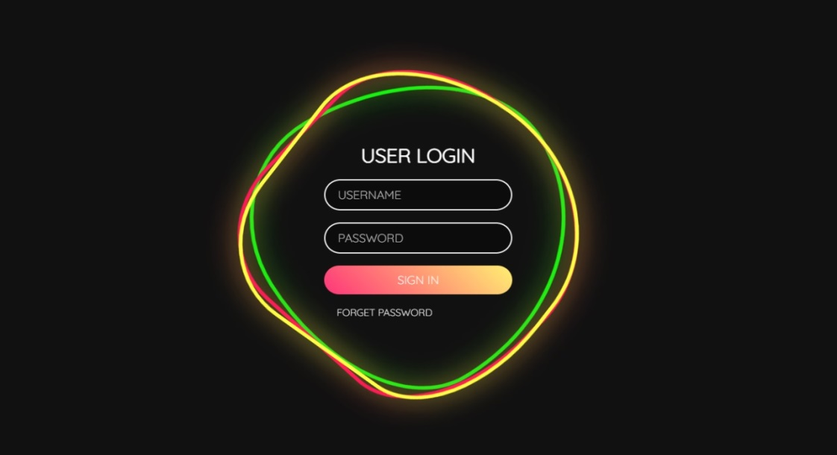

**4.2 USER LOGIN**

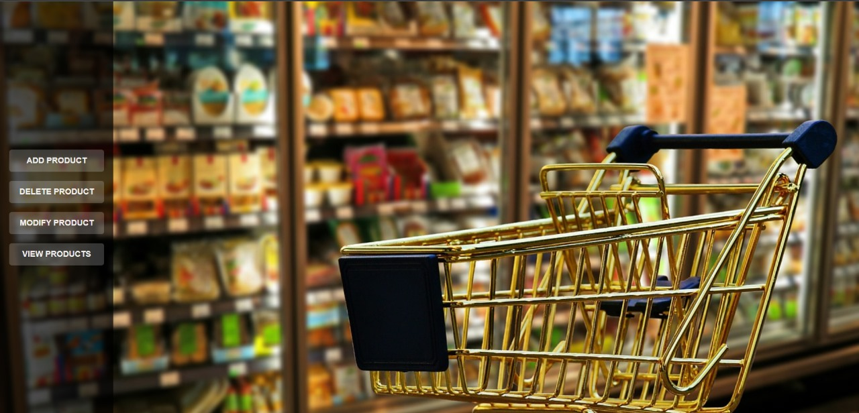

**4.2.1 ADD PRODUCT**

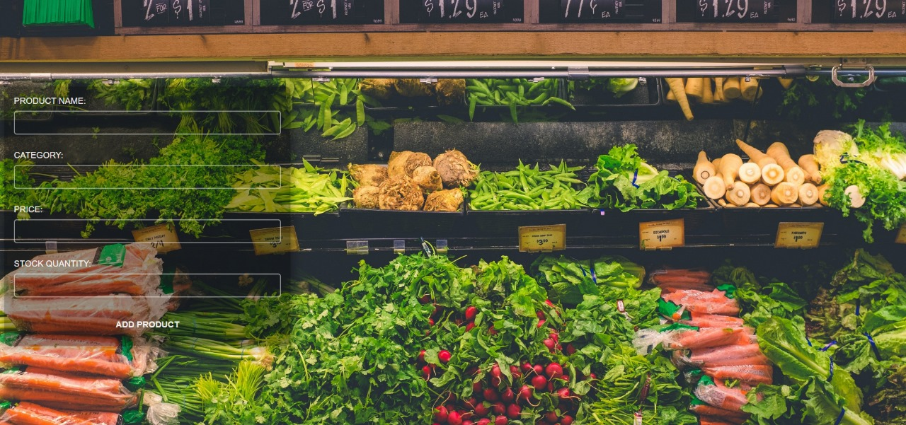

**4.2.2 DELETE PRODUCT**

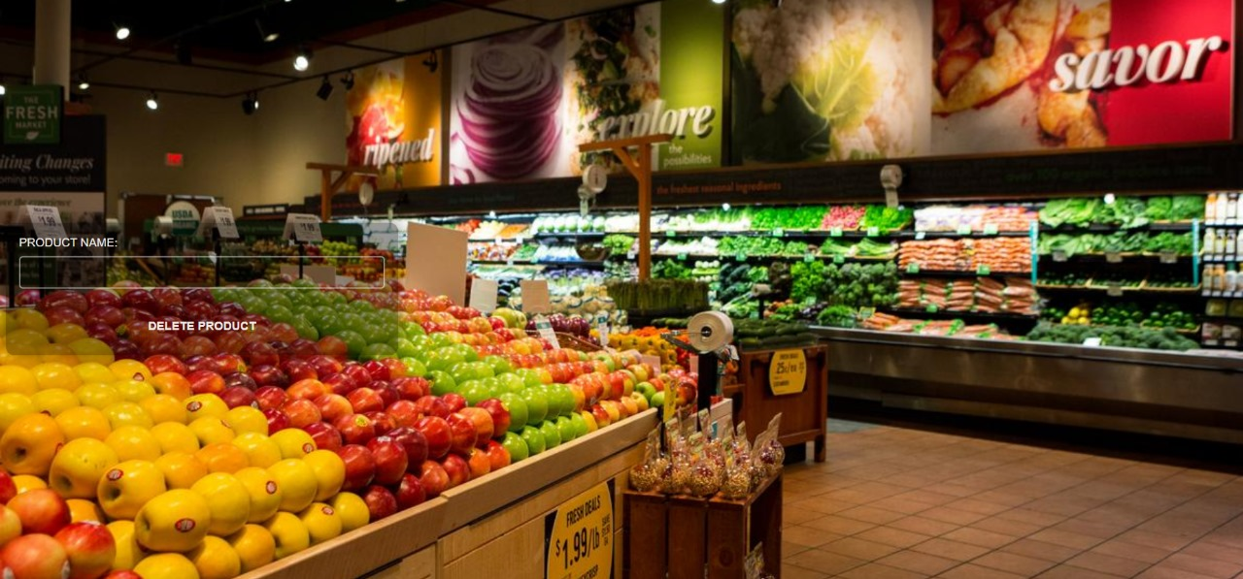

**4.2.3 MODIFY PRODUCT**

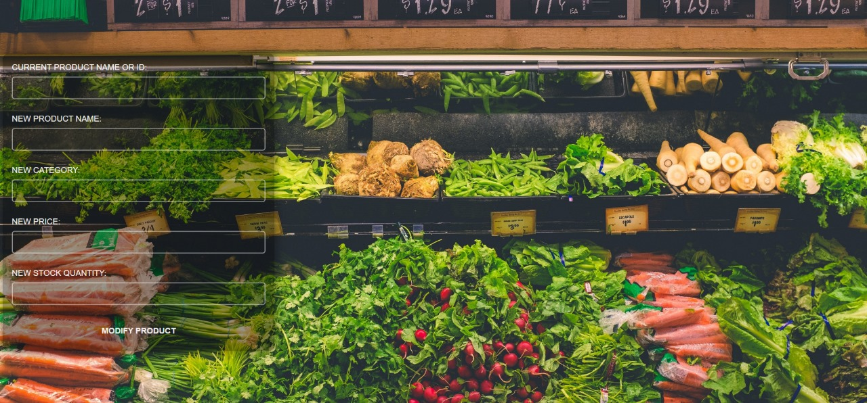

**4.2.4 VIEW PRODUCT**

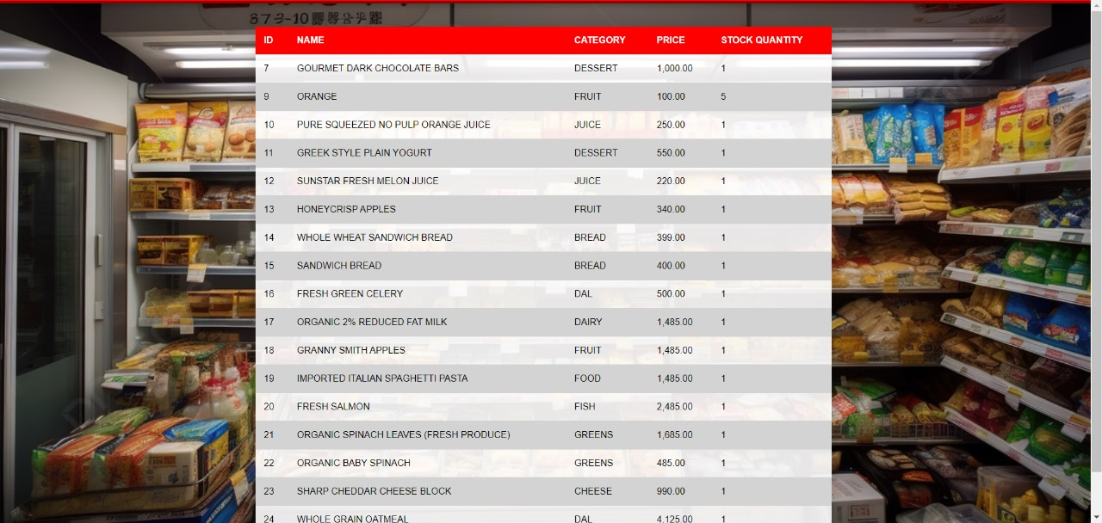

**4.3 USER LOGIN**

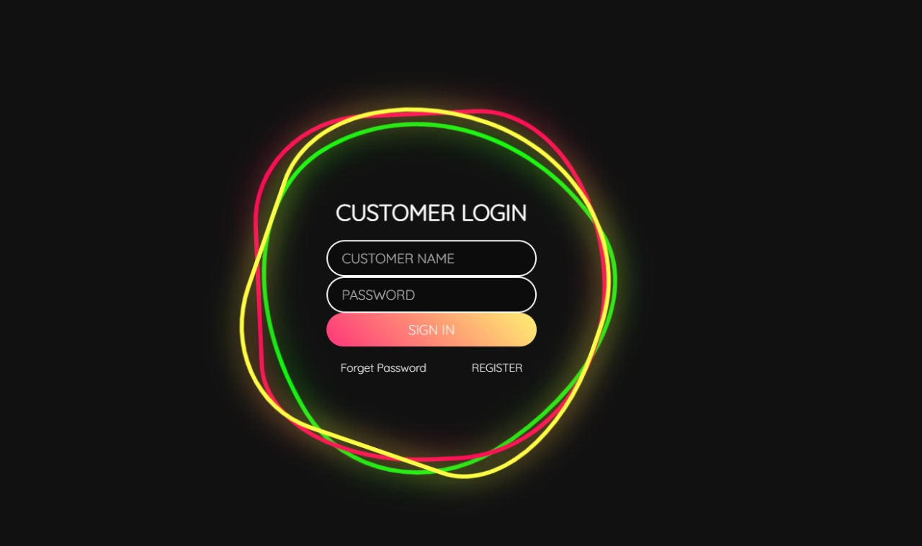

**4.3.1 CUSTOMER REGISTER PAGE**



**4.3.2 ONLINE PORTAL**

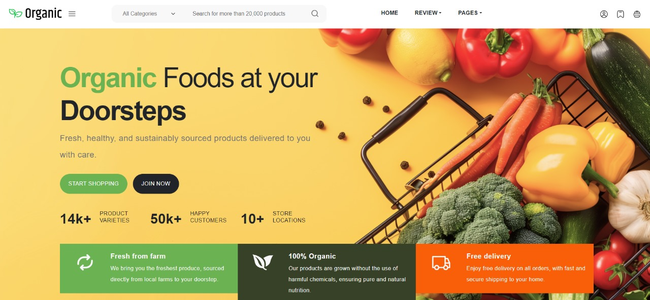

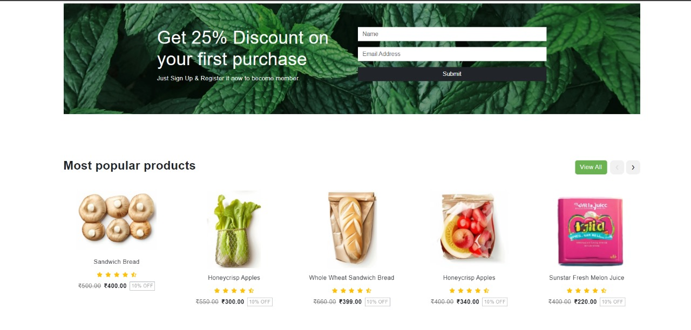

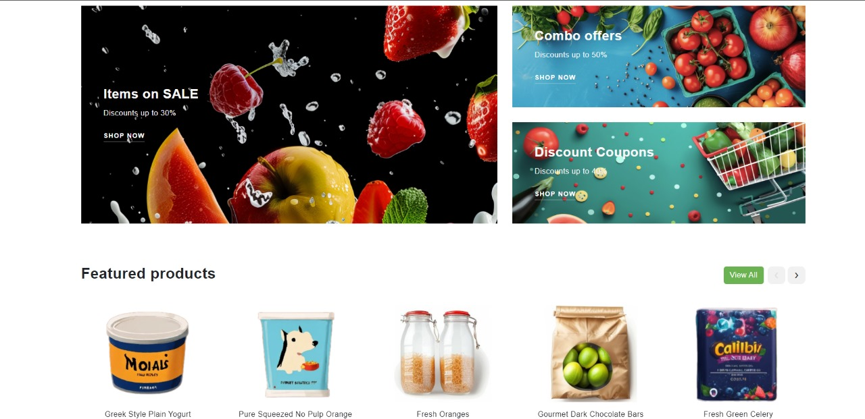

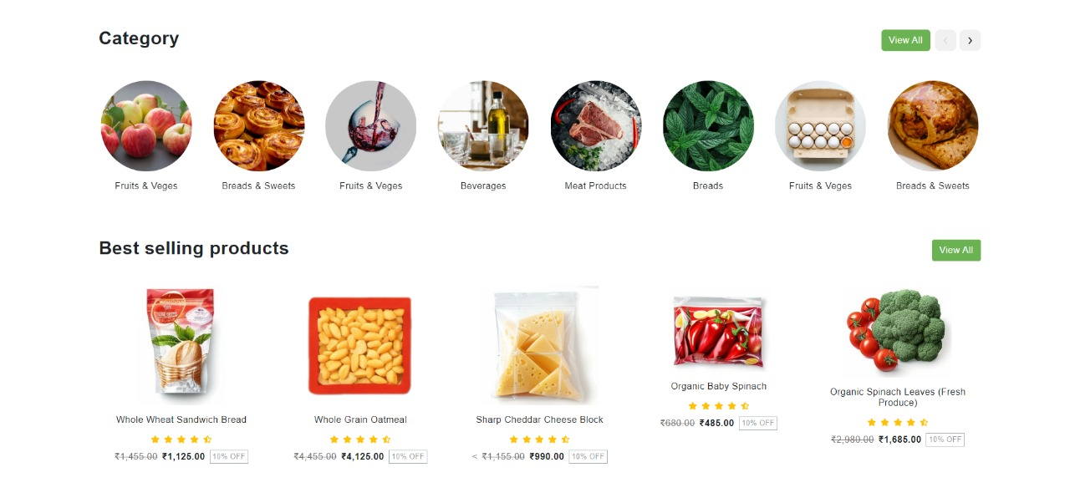

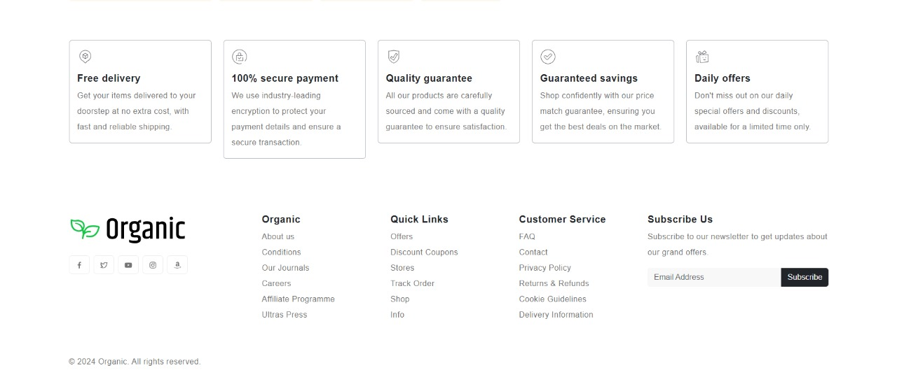

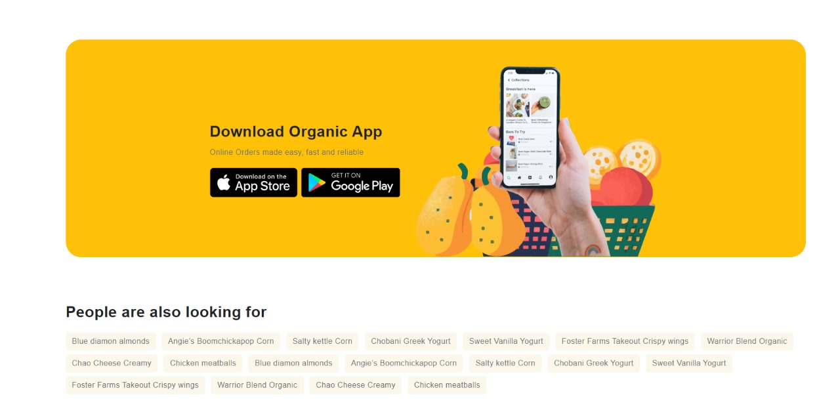

**4.4 CART**

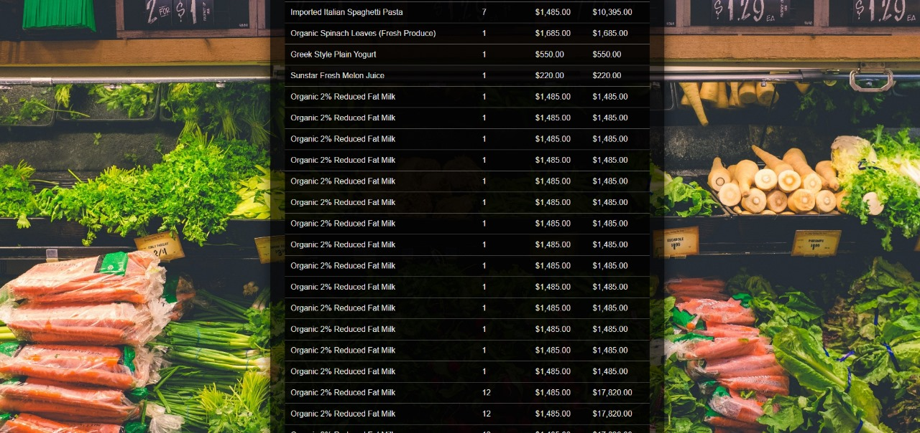

**4.5.1 CUSTOMER REVIEW**

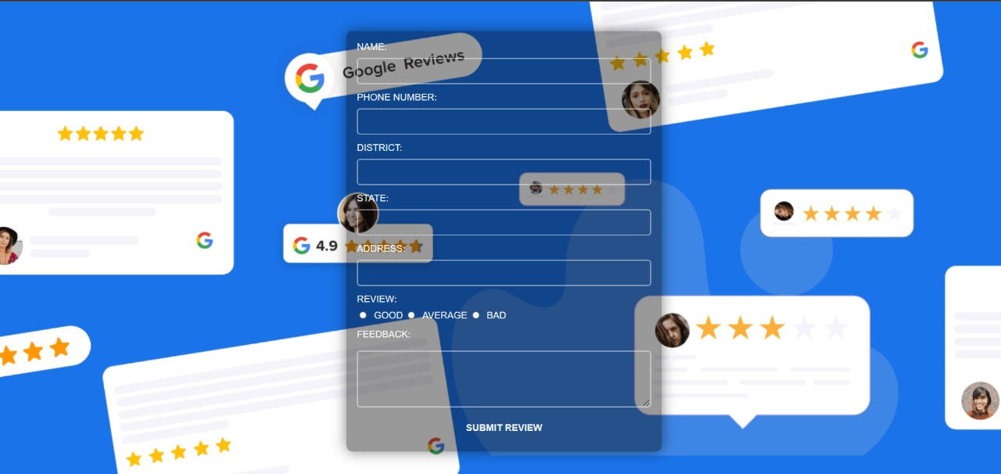

**4.5.2 PRODUCT REVIEW**

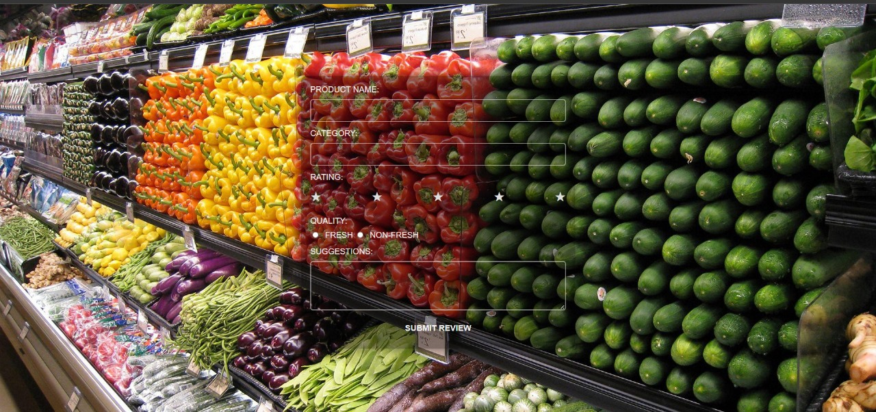

**SYSTEM TESTING**

System testing is a crucial phase of software development wherein the entire system is evaluated to ensure that it meets all requirements and operates as intended. It is completed after more basic testing activities, such as unit and integration testing, have been completed.

**5.1 Functional Testing**

Functional testing verifies that the system meets all specified requirements and operates as intended. Test cases for the Supermarket Management System could include:

|  |  |  |  |  |
| --- | --- | --- | --- | --- |
| **Test ID** | **Test Case** | **Expected Output** | **Observed Output** | **Result** |
| 1 | Customer registration with valid credentials. | Successful registration, user redirected to dashboard. | Successful registration, user redirected to dashboard. | Success |
| 2 | Customer attempts to login with incorrect credentials. | Login error message displayed. | Login error message displayed. | Success |
| 3 | Admin adds a new product to the catalog. | Product successfully added to the catalog. | Product successfully added to the catalog. | Success |
| 4 | Customer adds a product to their cart and proceeds to checkout. | Checkout process completed successfully, order confirmation sent. | Checkout process completed successfully, order confirmation sent. | Success |
| 5 | Admin views and updates an order status. | Order status updated successfully. | Order status updated successfully. | Success |
| 6 | Customer leaves a review for a product. | Review added successfully, displayed on product page. | Review added successfully, displayed on product page. | Success |
| 7 | Admin generates a sales report. | Sales report generated and displayed correctly. | Sales report generated and displayed correctly. | Success |
| 8 | System handles a large number of concurrent users without performance issues. | System remains responsive and handles the load without errors. | System remains responsive and handles the load without errors. | Success |

**5.2 User Interface Testing**

User interface (UI) testing evaluates the visual representation and usability of the system. Test cases could focus on:

* **Layout and Design:** Check for consistent layout, color schemes, and font usage throughout the application.
* **Navigation:** Verify that menus, buttons, and links are intuitive and easy to use.
* **Error Messages:** Ensure that error messages are clear and informative.
* **Accessibility:** Test for compliance with accessibility standards to accommodate users with disabilities.
* **Responsiveness:** Verify that the system adapts to different screen sizes and resolutions.

**UI Testing Checklist:**

* Check for consistency in font size, color, and spacing.
* Verify that all buttons and links are functional.
* Ensure that error messages are clear and helpful.
* Test the system on different devices and screen sizes.
* Verify that the system is accessible to users with disabilities.

By conducting thorough functional and UI testing, you can ensure that the Supermarket Management System meets the requirements, provides a positive user experience, and operates effectively.

**CHAPTER – 6**  
 **CONCLUSION**

**Supermarket Management System** has revolutionized the way supermarkets operate by providing a comprehensive and user-friendly online platform. The system empowers customers to browse a wide range of products, add them to their carts, and checkout securely from the comfort of their homes.

For administrators, the system streamlines inventory management, order processing, and customer data analysis. Key features such as product management, sales tracking, and reporting have significantly improved efficiency and decision-making.

**Key Achievements:**

* **Enhanced Customer Experience:** The system provides a convenient and intuitive online shopping experience, allowing customers to easily find and purchase products.
* **Improved Efficiency:** Streamlined operations, reduced manual tasks, and improved accuracy through automation.
* **Data-Driven Decision Making:** Access to real-time data and analytics enables informed decision-making regarding inventory management, pricing, and marketing strategies.
* **Increased Sales and Revenue:** The online platform has expanded the customer base and increased sales, leading to higher revenue generation.

**Future Enhancements:**

* **Customer Reviews:** Enable customers to leave reviews and ratings on products, fostering trust and transparency.
* **Personalized Recommendations:** Utilize customer data to suggest products tailored to individual preferences, enhancing the shopping experience.
* **Loyalty Programs:** Implement a loyalty program to reward repeat customers and encourage repeat purchases.
* **Mobile App:** Develop a mobile app for on-the-go shopping and increased convenience.
* **Integration with Delivery Services:** Partner with delivery services to offer convenient home delivery options.
* **Integration with Payment Gateways:** Expand payment options to include popular digital wallets and payment methods.
* **Social Media Integration:** Leverage social media platforms to engage with customers, promote products, and drive traffic to the online store.

**Conclusion:**

**Supermarket Management System** has laid a strong foundation for modernizing supermarket operations. By continuously evolving and incorporating new features, the system will continue to enhance customer satisfaction, improve efficiency, and drive business growth. The system's ability to adapt to changing market trends and customer needs positions it as a valuable tool for supermarkets seeking to thrive in the digital age.

As the retail landscape continues to evolve, **Supermarket Management System** will remain at the forefront of innovation, providing supermarkets with the tools and capabilities needed to succeed in a competitive market.

**BIBLIOGRAPHY**

* Silberschatz, Abraham, Henry F. Korth, and S. Sudarshan. Database System Concepts. 6th ed., McGraw-Hill, 2010.
* Elmasri, Ramez, and Shamkant B. Navathe. Fundamentals of Database Systems. 7th ed., Pearson, 2016.
* Welling, Luke, and Laura Thomson. PHP and MySQL Web Development. 5th ed., Addison-Wesley, 2016.
* Duckett, Jon. HTML and CSS: Design and Build Websites. Wiley, 2011.
* <https://www.w3schools.com/css/>
* <https://www.w3schools.com/html/>
* <https://www.w3schools.com/js/default.asp>
* <https://www.w3schools.com/php/>
* <https://learn.oracle.com/ols/course/oracle-database-19c-sql-fundamentals/88387/90084>